
RAMAIAH
Institute of Technology
USN | 1 | M | S

(Autonomous Institute, Affiliated to VTU)
(Approved by AICTE, New Delhi & Govt. of Karnataka) Accredited by NBA & NAAC with ‘A’ Grade

SEMESTER END EXAMINATIONS – JUNE 2019

Course & Branch | : | B.E.: Information Science and Engineering | Semester | : | IV
Subject | : | Design and Analysis of Algorithms | Max. Marks | : | 100
Subject Code | : | IS44 | Duration | : | 3 Hrs

Instructions to the Candidates:
- Answer one full question from each unit.

 |  | UNIT- I
1. | a) | Find gcd (31415, 14142) by applying Euclid’s algorithm. Estimate how many times faster it will be to find gcd(31415, 14142) by Euclid’s algorithm compared with the algorithm based on checking consecutive integers from min{m, n} down to gcd(m, n). | CO4 | (06)
 | b) | Write the pseudocode for finding the binary representation of a positive decimal integer. | CO2 | (05)
 | c) | For each of the following algorithms, indicate:  - a natural size metric for its inputs;  - its basic operation;  - whether the basic operation count can be different for inputs of the same size:  A) computing the sum of n numbers  B) computing n!  C) finding the largest element in a list of n numbers  D)Euclid’s algorithm  E)sieve of Eratosthenes  F)pen-and-pencil algorithm for multiplying two n-digit decimal integers. | CO2 | (09)
2. | a) | Define an algorithm. With a neat diagram write the steps involved in algorithm design and analysis process. | CO1 | (06)
 | b) | Consider the following algorithm.  Algorithm Mystery( n)  //Input: A nonnegative integer n  S ← 0  for i ← 1 to n do  S ← S + i * i  return S  i. What does this algorithm compute?  ii. What is its basic operation?  iii. How many times is the basic operation executed?  iv. What is the efficiency class of this algorithm? | CO2 | (04)
 | c) | i) Explain O - notation , θ - notation and Ω - notation. Which of the following functions belong to O(n³): 100n², 123, n!, 1200n³, 3n, 3^{n} ?  ii) Solve the following recurrence relation using backward substitution method,  x(n) = x(n/2) + n for n > 1, x(1) = 1 (solve for n = 2^{k}) | CO1 | (10)
 |  | UNIT– II
3. | a) | State Mergesort algorithm and analyze its efficiency. | CO2 | (08)
 | b) | Traverse the following Binary tree in: preorder, inorder and postorder  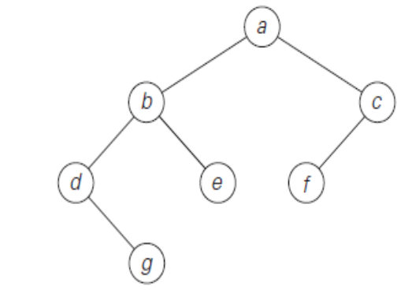  Analyze the efficiency of these traversal algorithms. | CO3 | (06)
 | c) | Sort the list E,X,A,M,P,L,E using Bubble sort. Is there any possibility that bubble sort can be stopped earlier. | CO1 | (06)
4. | a) | Arrange the characters in the string ‘QUICKSORT’ in alphabetical order using quicksort technique. Derive its worst case efficiency. | CO3 | (10)
 | b) | With pseudocode, explain how searching for pattern BARBER in the given text JIM_SAW_ME_IN_BARBER_SHOP is performed using Horspool algorithm. | CO2 | (10)
 |  | UNIT- III
5. | a) | Define greedy technique. Write Prim’s algorithm and apply the same for the following graph to find minimum spanning tree.  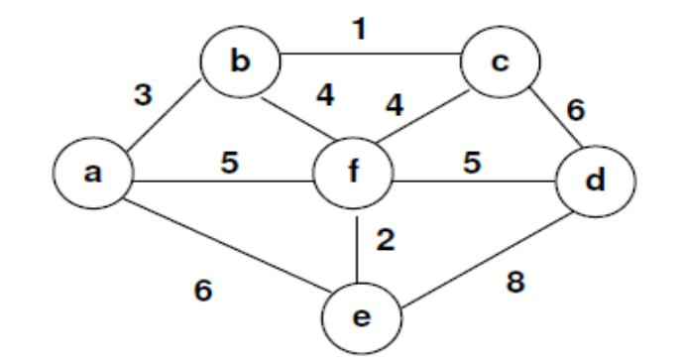 | CO2 | (10)
 | b) | Apply Dijkstra’s algorithm on the following graph to find the shortest path from node 1.  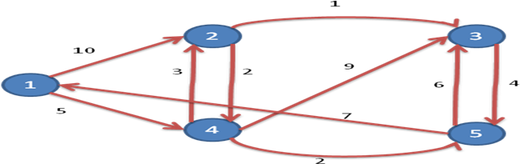 | CO4 | (10)
6. | a) | State the Greedy Knapsack?  Find an optimal solution to the knapsack instance n=7 objects and the capacity of knapsack m=10. The profits and weights of the objects are (P1,P2,P3, P4, P5,P6, P7)= (10, 5,15,7,6,18,3) (W1,W2,W3,W4,W5,W6,W7)= (2,3,5,7,1,4,1) | CO4 | (10)
 | b) | Suggest an algorithm to find all pairs of shortest paths given a weighted connected path using dynamic programming technique. Apply the same algorithm to compute all pairs of shortest path for the following weighted connected graph.  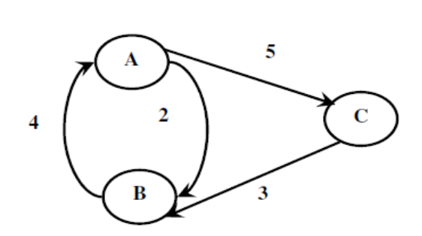 | CO2 | (10)
 |  | UNIT- IV
7. | a) | Write Breadth first search algorithm, traverse the given graph by breadth-first search and construct the corresponding breadth-first search tree. Start the traversal at vertex a and resolve ties by the vertex alphabetical order.  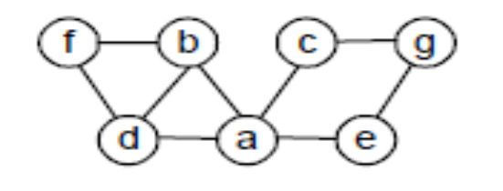 | CO4 | (09)
 | b) | Construct an AVL tree by successive insertion of elements 2,4,1,3,8,6,5. | CO4 | (05)
 | c) | Apply the DFS-based algorithm and source removal algorithm to solve the topological sorting problem for the given digraph.  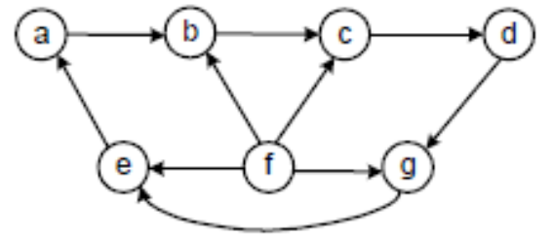 | CO4 | (06)
8. | a) | Which algorithm design technique is used to solve the fake-coin problem? Justify. | CO1 | (05)
 | b) | Explain Josephus problem with an example and the techniques that can be applied to solve the problem. | CO1 | (05)
 | c) | Write the algorithm for insertion sort and apply insertion sort to the list: I,N,S,E,R,T,I,O,N,S,O,R,T. | CO2 | (10)
 |  | UNIT- V
9. | a) | i) Construct a heap for the list 1, 8, 6, 5, 3, 7, 4 by the bottom-up algorithm.  ii) Construct a heap for the list 1, 8, 6, 5, 3, 7, 4 by successive key insertions (top-down algorithm).  iii) Is it always true that the bottom-up and top-down algorithms yield the same heap for the same input? | CO4 | (08)
 | b) | Draw the state space tree for n - Queens problem when n = 4 and explain the concept of backtracking. | CO5 | (10)
 | c) | Which of the following diagrams do not contradict the current state of our knowledge about the complexity classes P, NP, and NPC (Npcomplete Problems)?  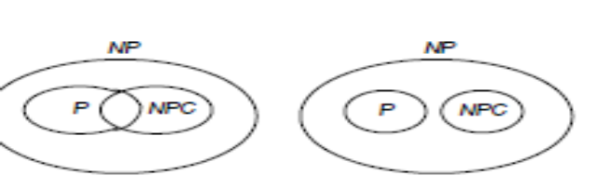  - b) | CO5 | (02)
10. | a) | i) Sort the following lists by heap sort by using the array representation of Heaps.  - 5, 4, 3, 2, 1 (in increasing order)  - S, O, R, T, I, N, G (in alphabetical order)  ii) Is heap sort a stable sorting algorithm?  iii) What variety of the transform-and-conquer technique does heap sort represent? | CO4, | (08)
 | b) | Define the following:  i) Tractable and Intractable problems  ii) Class P problems with an example  iii) A Nondeterministic algorithm  iv) When is a decision problem D said to be NP - complete?  v) Polynomial Time Reducibility. | CO1 | (10)
 | c) | Mention any two major differences between branch and bound and backtracking algorithms. | CO1 | (02)

****************

